ComicCraft: AI Comic Story Creator using Gemini Models

Project Description:
ComicCraft is a web-based AI comic creation platform that helps users transform a simple story idea into a complete five-panel comic. The user provides a story prompt, character name, setting, tone, and preferred art style. ComicCraft then generates a structured comic outline, narration, character dialogue, comic-style illustrations, a panel-by-panel preview, and a downloadable PDF.

The application uses generative AI to coordinate story and image creation. Gemini Flash is used for the structured comic outline, Gemini Pro is used for narration and dialogue generation, and an image-generation pipeline is used to create comic illustrations. FastAPI manages the application workflow, while Jinja2 templates provide the web interface. Generated panels and exported PDF files are stored in the project folders.
The project is designed for students, aspiring storytellers, casual comic creators, and users who want to create a visual story without manually drawing every panel.

Scenarios
Scenario 1: A student has an idea for a short adventure story. The user enters the story prompt, character name, setting, tone, and art style. ComicCraft generates a five-panel comic with narration, dialogue, and illustrations that can be previewed and exported as a PDF.

Scenario 2: A user wants to create a short fantasy comic but does not have drawing skills. The user selects a fantasy setting and preferred art style, and ComicCraft generates the panel structure, story text, and corresponding illustrations.
The generated panels are displayed together so the user can review the complete story before downloading the final comic.

Scenario 3: A user wants to turn a personal story idea into a shareable comic. The user provides the characters and setting, selects a suitable tone and art style, generates the comic, and downloads the completed PDF.
The workflow reduces the need for separate story-writing, image-generation, panel-layout, and PDF-formatting tools.

Technical Architecture:
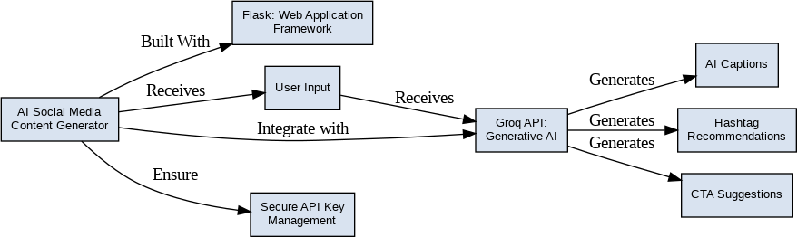
Description: ComicCraft follows a modular web application architecture. The frontend uses HTML, CSS, and Jinja2 templates to collect user inputs and display the generated comic. FastAPI and Uvicorn handle HTTP requests and coordinate the generation workflow. Gemini Flash creates the structured five-panel outline, Gemini Pro generates narration and dialogue, and the image-generation component creates illustrations. Layout and PDF export modules combine the generated content into the final comic.

Note: The current ComicCraft version does not use a database or user authentication. Generated panel images and exported PDF files are stored in the project's static folders.

Pre-requisites:
- FastAPI and Uvicorn Knowledge: Basic understanding of Python web applications and API servers.
- Generative AI / Gemini API Familiarity: Basic understanding of Gemini model integration and API keys.
- HTML, CSS, and Jinja2 Skills: Basic frontend and template knowledge for editing the ComicCraft interface.
- Python Programming Proficiency: Python fundamentals, virtual environments, packages, and file handling.
- Version Control with Git: Basic Git/GitHub knowledge for managing the project source code.
- Development Environment Setup: VS Code, Python virtual environment, pip, and Uvicorn.
- Image/PDF Generation Knowledge: Basic understanding of image processing and PDF generation using the project's libraries.

Project Workflow:

Milestone 1: AI Model Selection and Architecture
- Activity 1.1: Configure the required Gemini and image-generation API credentials securely in the local environment.
- Activity 1.2: Select Gemini models for structured comic planning and detailed story/dialogue generation, together with an image-generation model for panel illustrations.
- Activity 1.3: Define the architecture connecting the web interface, FastAPI backend, AI services, image generation, layout builder, and PDF exporter.
- Activity 1.4: Set up the Python virtual environment and install all required project dependencies.

Milestone 2: Core Comic Generation Development
- Activity 2.1: Develop the core comic workflow: user input, five-panel outline, narration/dialogue, image generation, panel layout, and PDF export.
- Activity 2.2: Implement FastAPI routes to validate input, coordinate AI services, generate the comic, and return the preview/export result.

Milestone 3: Backend Application Development
- Activity 3.1: Develop the main FastAPI application and route handlers for the home page, comic generation, JSON generation, and testing endpoints.

Milestone 4: Frontend Development
- Activity 4.1: Design the comic creation interface using HTML and CSS with Jinja2 templates.
- Activity 4.2: Create dynamic templates to display generated panels, narration, dialogue, and export status.

Milestone 5: Local Deployment and Testing
- Activity 5.1: Prepare the application for local deployment by activating the Python virtual environment and installing dependencies.
- Activity 5.2: Run the FastAPI application with Uvicorn and verify comic generation, panel loading, and PDF export.

Milestone 6: Conclusion

Milestone 1: AI Model Selection and Architecture
This milestone focuses on selecting and integrating the AI components required for ComicCraft. The workflow separates story planning, story expansion, illustration generation, layout construction, and PDF export so that each part of the system has a clear responsibility.

Activity 1.1: Configure AI API Credentials
ComicCraft requires the appropriate API credentials to communicate with its external generative AI services. Store the required keys in the local environment and never commit real credentials to the repository.
- Step 1 — Create/obtain the required API credentials for the AI services used by the project.

- Step 2 — Add the required credentials to the local .env file used by the application.

- Step 3 — Ensure the configuration module reads the credentials through the project's settings/environment configuration.

- Step 4 — Verify the application can start without exposing API keys in source code or public documentation.

- Step 5 — Keep the .env file out of version control and provide placeholder values in an example environment file when required.
- Step 6 — Verify the configured models and output directories are available before running comic generation.
The application loads its configuration at startup and uses the configured credentials when making AI generation requests.
The configuration contains model names, provider settings, output directories, prompt limits, and request timeout/retry settings.
- Important — Never Commit API Keys: Keep .env and other secret credential files excluded through .gitignore.
.env

Activity 1.2: Select the Appropriate Generative AI Models
The model selection process for ComicCraft considers the requirements of structured story planning, detailed narration/dialogue, and comic-style image generation.
  - Understand the Project Requirements: The application must transform a user prompt into a consistent five-panel comic with story text and corresponding illustrations.
  - Explore Model Capabilities: Review the available Gemini and image-generation model capabilities, input limits, output formats, and generation requirements.
  - Evaluate Model Performance: Consider response quality, generation speed, prompt adherence, and suitability for comic storytelling and image creation.
  - Model Selection: Gemini Flash is used for the structured comic outline, Gemini Pro for detailed narration and dialogue, and the configured image-generation pipeline for comic panel illustrations.

Activity 1.3: Define the Architecture of the Application
  - Draft an Architectural Diagram: Represent the flow from the browser interface to FastAPI, AI generation services, image generation, layout building, and PDF export.
  - Detail Frontend Functionality: Users enter a story prompt, character name, setting, tone, and art style, then submit the form to generate the comic.
  - Outline Backend Responsibilities: FastAPI receives and validates input, coordinates the AI calls, prepares panel data, builds the comic layout, and handles PDF export.
  - Describe AI Integration Points: The application sends structured prompts to the selected Gemini models and uses the returned story/image information to build the final five-panel comic.

Activity 1.4: Set Up the Development Environment
  - Install Python and Pip: Ensure a compatible Python installation is available together with pip.
  - Create a Virtual Environment: Set up a .venv environment to isolate the ComicCraft dependencies.
D:\projects>python -m venv myenv D:\projects>"d:\projects\venv\Scripts\activate"
(myenv) D:\projects> pip install -r requirements.txt
  - Install Project Dependencies: Run pip install -r requirements.txt from the activated virtual environment.
(myenv) D:\projects> pip install Flask==3.0.3
  - Configure the AI SDKs and image/PDF libraries required by the project.
  - Keep environment variables and API credentials in the local .env configuration.
(myenv) D:\projects> pip install python-dotenv==1.0.1
  - Configure the Output Directories: Ensure the application can write generated panels and PDF exports to the project's static folders.
Generated panel images and exported PDF files are stored under the project's static output locations.
  - Set Up Application Structure: Keep the app modules, templates, static files, tests, configuration, and dependency files organized in the project directory.
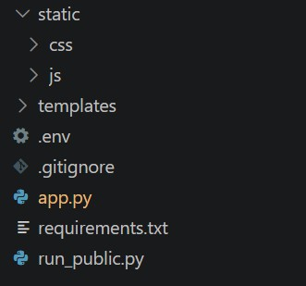

Milestone 2: Core Comic Generation Development

Activity 2.1: Develop Core Comic Generation Features
Implement the core generation workflow as a coordinated sequence: user input → five-panel outline → narration/dialogue → panel illustrations → comic layout → PDF export.
  - Story Outline Generator: Creates a structured five-panel outline based on the user's story prompt, character, setting, tone, and art style.
  - Narration and Dialogue Generator: Produces the story narration and character dialogue required for each panel.
  - Image Generator: Produces comic-style illustrations corresponding to the panel image prompts.

Activity 2.2: Implement the FastAPI Backend

Define Routes in FastAPI:
- Set up routes for the home page, comic generation, JSON generation, and image/testing operations.

Process User Input:
- Create the comic-generation form for story prompt, character name, setting, tone, and art style.
- Use FastAPI request handling and schema validation to process form and JSON input.
- Validate the required input values and enforce configured prompt-length limits before sending requests to the AI services.

Integrate AI Calls:
- Use the application service modules to construct prompts and request the structured comic outline and detailed story content.
- Use the configured Gemini models and image-generation service to create the comic content and illustrations.
- Process the generated data, handle API failures/retries where configured, and pass the resulting panel information to the layout/export modules.

Milestone 3: Backend Application Development
Milestone 3 focuses on developing the FastAPI application that coordinates user input, AI generation, image creation, layout construction, and PDF export.

Activity 3.1: Writing the Main Application Logic

Define the Core Routes:
- Establish routes for the ComicCraft home page and comic generation workflow.
  - / — Home page route that renders the main comic creation interface.

  - /generate — POST endpoint that accepts comic input, invokes the generation workflow, and returns the generated comic result.

)
response_text = chat_completion.choices[0].message.content result = extract_json(response_text)
# Validate structure
if not all(k in result for k in ["captions", "hashtags", "ctas"]): raise ValueError("Invalid response structure from AI")
return jsonify({ "success": True,
"captions": result["captions"], "hashtags": result["hashtags"], "ctas": result["ctas"], "platform": platform,
"tone": tone
})
except ValueError as e: import traceback traceback.print_exc()
return jsonify({"error": f"Failed to parse AI response: {str(e)}"}), 500 except Exception as e:
import traceback traceback.print_exc()
return jsonify({"error": f"Generation failed: {str(e)}"}), 500

Set Up Route Handlers for Each Feature:
- The /generate route receives the user's story prompt, character name, setting, tone, and art style and passes the validated values to the comic-generation services.
- Apply input validation and return an appropriate error response when required information is missing or invalid.
- Route browser requests to the generation workflow and return the preview/export result to the frontend.

Define Prompt and Generation Helpers:
- Use dedicated service functions to create the outline, story text, image prompts, and final panel layout.

TONE_DESCRIPTIONS = {
"professional": "formal, authoritative, and business-oriented. Use clear, concise language that conveys expertise and credibility.",
"casual": "friendly, conversational, and relatable. Use informal language, emojis, and a warm tone that feels personal.",
"promotional": "exciting, persuasive, and action-driven. Use power words, urgency, and compelling offers to drive engagement."
}

- Use the configured story and image model settings to control the AI generation process.

- Build the comic layout from the generated panel information and prepare the content for PDF export.

Integrate the AI Responses in Each Function:
- Send structured prompts to the configured Gemini models and process the returned story information.
- Handle generated content safely and pass panel data to the image-generation and export components.

- Validate that the generated result contains the required panel information before creating the final comic.
- Home route: / → renders the comic creation interface; /generate (POST) → generates the comic and returns the result.
The final result contains the five-panel comic data, generated images, story text, and PDF export information.

Milestone 4: Frontend Development
Milestone 4 focuses on creating a simple and user-friendly interface for entering comic details and viewing the generated five-panel comic.

Activity 4.1: Designing and Developing the User Interface

Set Up the Base HTML Structure:
- Develop the main input template with fields for story prompt, character name, setting, tone, and art style, together with a comic-generation button.
- Use clear form labels and organized sections so users can provide the required information easily.
- Use the project's CSS and template structure to present a consistent ComicCraft interface.

Design the Comic Preview Layout:
- Create a responsive layout for displaying the generated comic panels and their associated story information.
- Use a panel-based arrangement to show each generated illustration together with its title, narration, dialogue, or scene description.
- Keep the preview readable across the supported browser window sizes.

Create Separate UI Components for Each Panel:
- Panel cards: display the generated illustration and panel title.
- Story text: display the narration, dialogue, captions, and scene information associated with each panel.
- Export controls: provide access to the generated PDF and the export-success confirmation.

Activity 4.2: Creating Dynamic Content Rendering

Handle Form Submission:
- Submit the user's comic information to the FastAPI generation endpoint and wait for the generated result.
- During generation, provide appropriate feedback so the user knows that the comic is being created.

Render Results Dynamically:
- Use the Jinja2 templates and returned generation data to display the generated panels and story information.
- After generation, present the completed comic in a panel-by-panel preview.

Restore UI State After Generation:
- After success or failure, restore the interface so the user can review the result or generate another comic.

Milestone 5: Local Deployment and Testing
In Milestone 5, the focus is on running ComicCraft locally, verifying the generation workflow, and confirming that the generated panels and PDF export work correctly.

Activity 5.1: Preparing the Application for Local Deployment

Set Up a Virtual Environment:
- Open a new VS Code terminal.
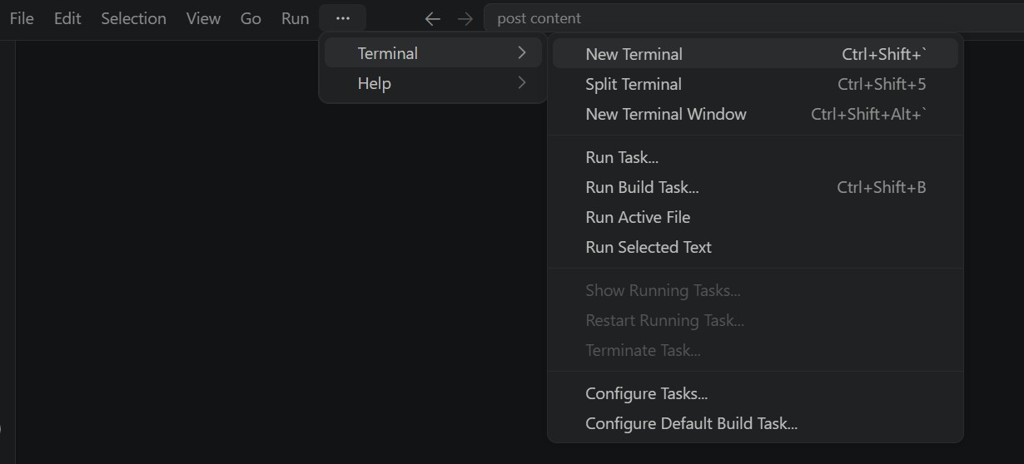
- Activate the ComicCraft Python virtual environment.
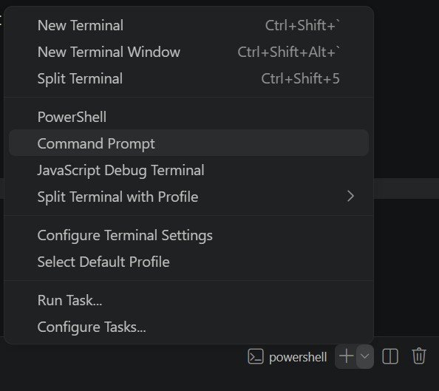

- Install all required dependencies from requirements.txt.
D:\projects>python -m venv myenv D:\projects>"d:\projects\venv\Scripts\activate" (myenv) D:\projects>pip install -r requirements.txt

Configure Environment Variables:
- Create/configure the local .env file with the required AI service credentials and application settings.
Keep the .env file private and excluded from source control.

Activity 5.2: Local Testing and Verification

Start the FastAPI Development Server:
- Run the application locally using:
(myenv) D:\projects>python app.py
- python -m uvicorn app.main:app --reload
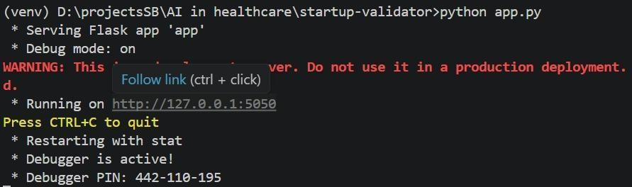
- Open http://127.0.0.1:8000 in the browser. Test comic generation, panel loading, preview, and PDF export. The documented test run showed GET / and POST /generate returning successful HTTP responses, all five panel image requests returning 200 OK, and the generated PDF returning 200 OK.

Activity 5.3: Deployment / Access
The current project is configured for local deployment through Uvicorn. A hosted public URL is not required for the current local version.

Local Server:
- Run the FastAPI application from the activated virtual environment.
D:\projects>pip install pyngrok
- Open the local application URL in a browser.
- http://127.0.0.1:8000
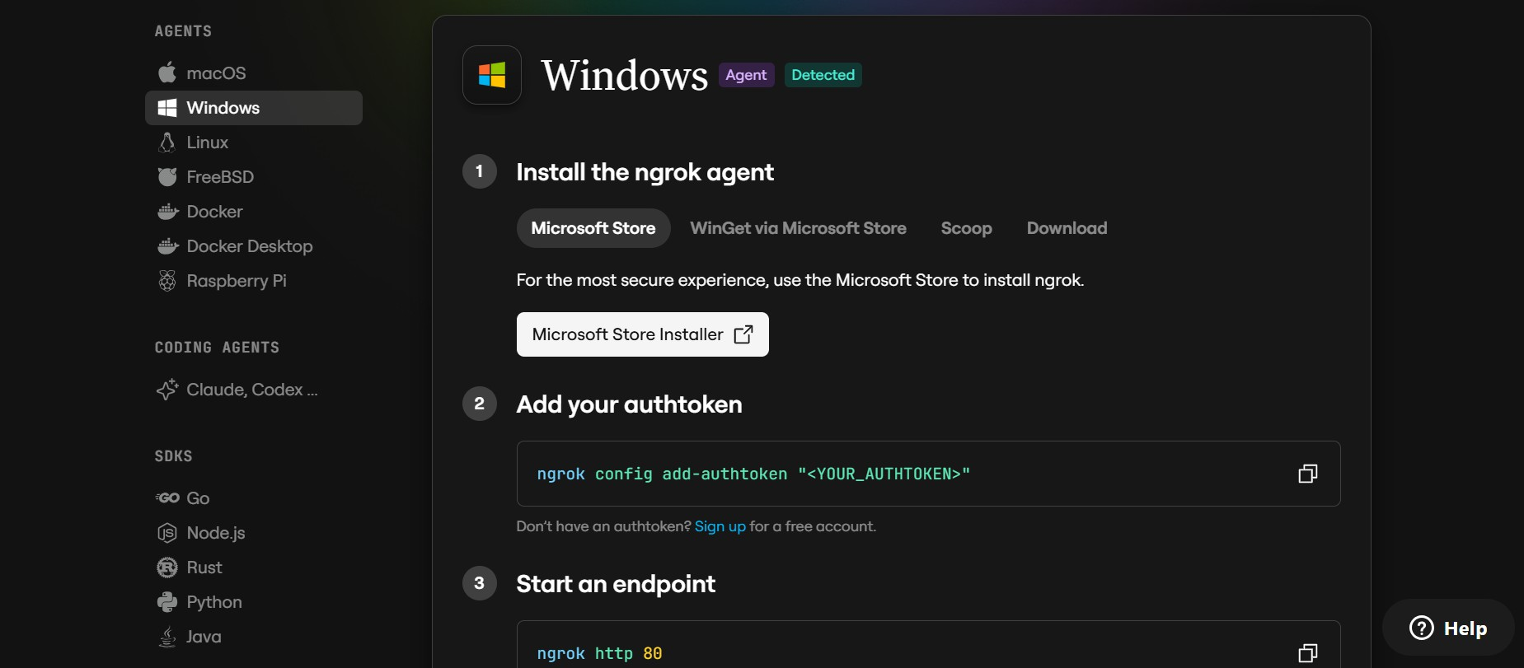

Environment Configuration:
- Keep API credentials in the local .env file and do not expose them in screenshots, source control, or public documentation.
- Use the configured settings module to load the application configuration.
D:\projects>ngrok.set_auth_token("YOUR_NGROK_AUTHTOKEN")
- Repository / Submission:

Include the source code, requirements.txt, README/setup instructions, tests, templates, static files, and other required project files in the submission.
- The evaluator can reproduce the local environment using the project setup instructions and the Uvicorn command.
- Local access URL:
======================================================
URL: http://127.0.0.1:8000
======================================================

- The application can be accessed from the same machine while the local Uvicorn server is running.

Important Notes:
- The local Uvicorn server must remain running while the application is being accessed through the browser.
- The current version does not include a hosted deployment URL, user authentication, or a database-backed comic history.
- AI generation requires the configured external AI services and appropriate API credentials.

Exploring the Website’s Web Pages:

Home / Comic Generator Page:
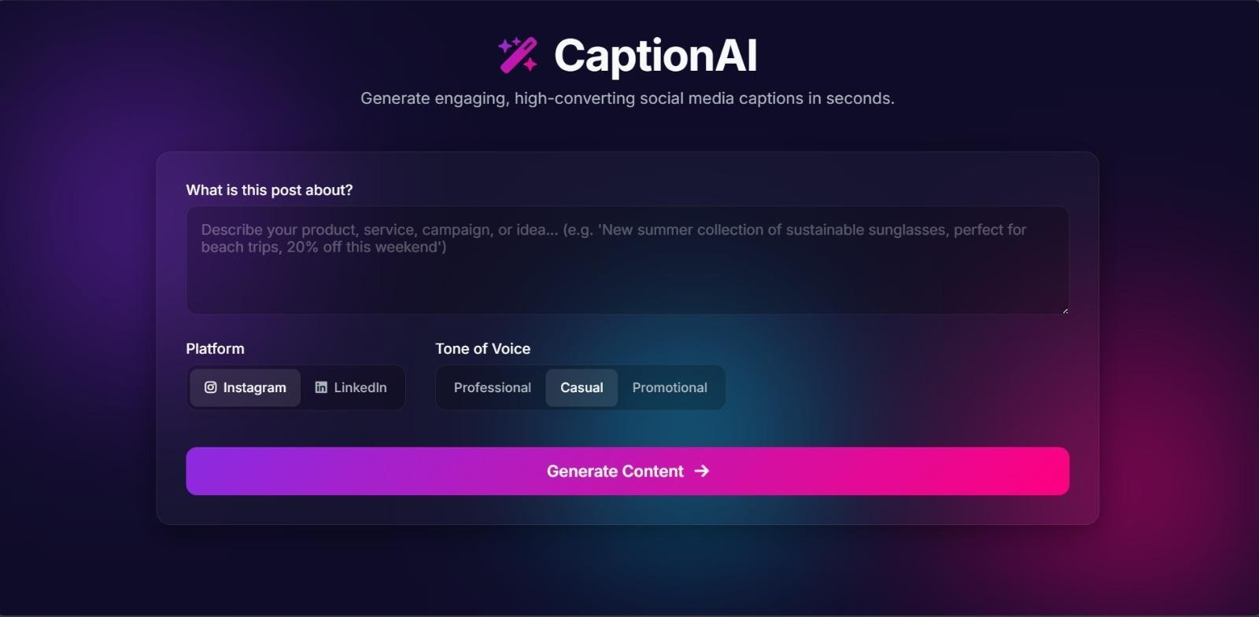
Description: The ComicCraft home page provides the main comic-generation interface. It allows the user to enter the story prompt, character name, setting, tone, and art style and start the AI comic-generation workflow.

Input Section:
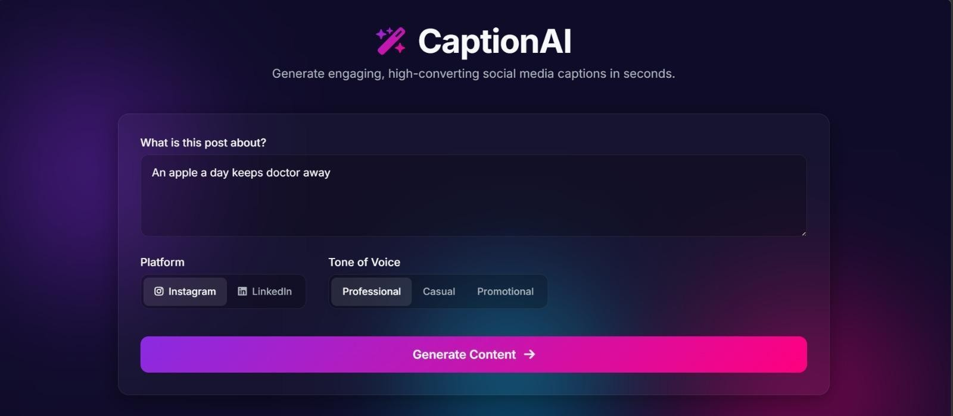
Description: The input section collects the information required to personalize the comic. After the user submits the form, the backend generates the structured story and panel content.

Comic Preview Section:
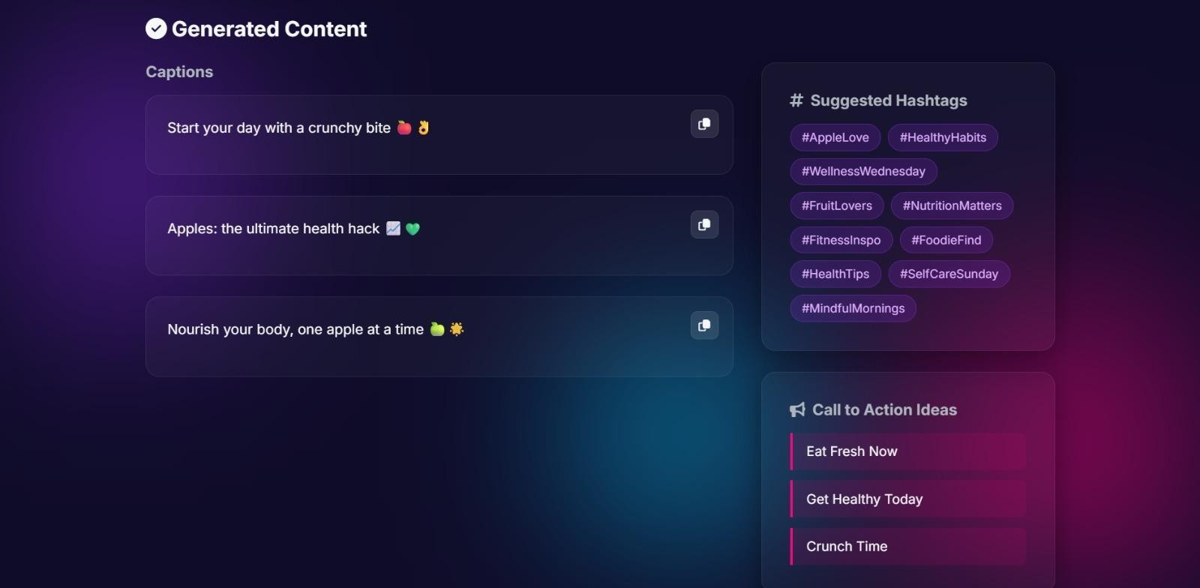
Description: After generation, the preview displays the completed comic panel-by-panel. Each panel contains its generated illustration together with the associated story information.
The final comic can be exported as a PDF for saving, sharing, or submission.

Conclusion:
ComicCraft is a generative AI web application that helps users transform story ideas into complete five-panel comics. It combines FastAPI, Jinja2, Gemini-based story generation, image generation, layout construction, and PDF export into one workflow. The project demonstrates how generative AI can reduce the manual effort involved in comic writing, illustration, panel arrangement, and formatting while giving users a simple interface for creating personalized visual stories. Future improvements can include user accounts, comic history, additional page layouts, stronger character consistency, more art styles, and hosted deployment.

